Argument reconstruction and assessment
In this essay I am assessing an argument from Rachel Connolly’s “For people on low incomes, free Internet access would be life-changing”. standard form of the argument is summarized as follows:
Argument 1:
P1) A lack of Internet access created barriers in terms of school work for the writer Rachel when he or she is a student.
C1) A lack of Internet access creates barriers in terms of school work for students.
P2) If something creates barriers for students, it should be removed.
P3) The benefit of not creating barriers for students outweighs the cost of removing barriers
C2) The problem of lack of Internet access should be solved for students.
P4) The poor are like students.
C) Poor people deserve free Internet access.
Argument 2
P5) “Digital by default” design of universal credit prevents many people who do not have access to the Internet from access to entitlements.
P6) More than half of those on low incomes do not have broadband Internet at home.
C3) “Digital by default” design of universal credit prevents many poor people from access to entitlements.
P7) All the poor have the right to access entitlements.
P8) The benefit of ensuring that the poor have the right to access entitlements outweighs the cost of providing the poor with free Internet access.
C) Poor people deserve free Internet access.
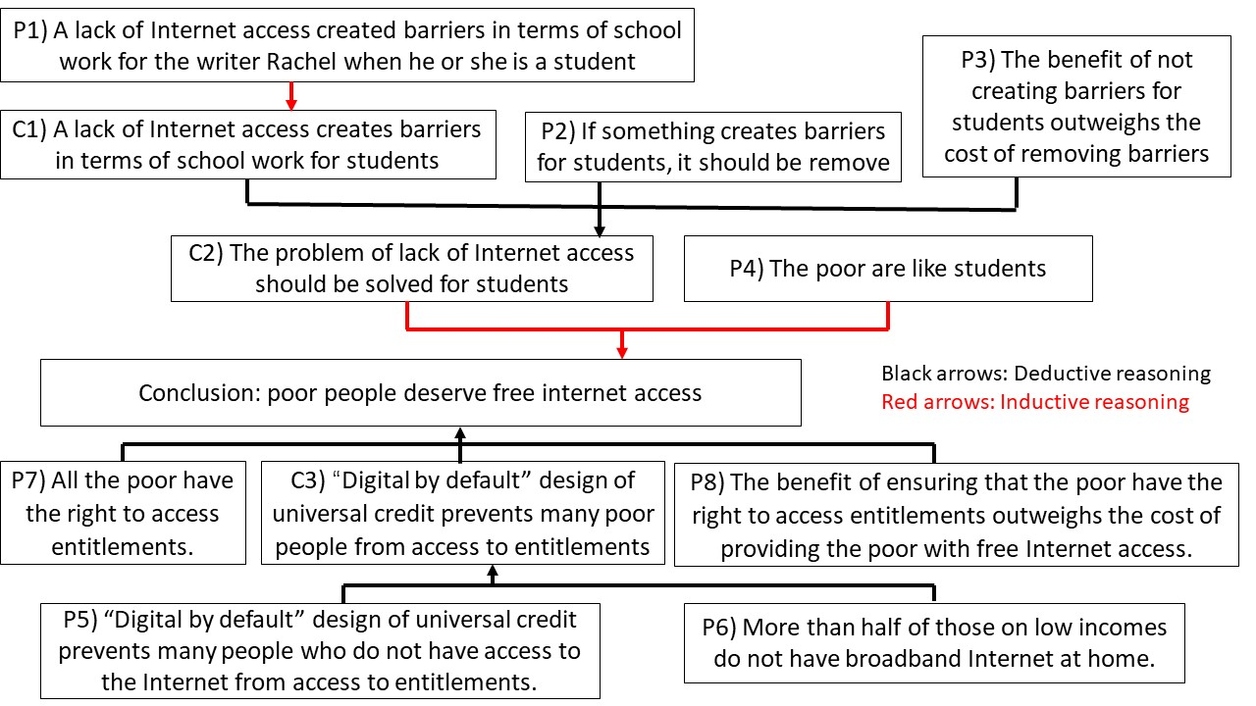

By checking the truth of the premises and how those premises are assembled in support of the conclusion, Argument 1 is unsound because although the premises are true, it included unforceful inductive reasoning; Argument 2 is sound because the premises are all true and the reasoning is good.
Examining the truth of premises is crucial to accept the soundness of the argument. By telling the story of how the writer was hindered in learning as a student who lacked Internet access ten years ago, Rachel shows P1 is true. P6 is true because it is supported by data: “47% of those on low incomes have broadband Internet at home” which means more than half of the poor do not have broadband Internet at home. So, the beginning premises are all true.
Subsequently, inspecting the argument structure helps to examine whether the premises effectively support the conclusion or not. In argument 1 Rachel used his or her personal experience as an observed sample, and implicitly assume that other students will be in a similar predicament, therefore, the intermediary conclusion C1 about the population has been reached. However, Rachel alone as a sample can’t really represent millions of students who lack Internet access, and Rachel did not prove that the implicit assumption is true, it is an unforceful inductive argument based on statistics. The inference from C1, P2 and P3 to C2 is called modus ponens which is a valid argument form. There P2 as a conditional statement is accepted, the antecedent C1 holds and P3 as a comparison of gains and losses is accepted, the consequent C2 as a suggested action can be inferred. In the next step, a forceful inductive argument based on analogy is employed because both students and the poor are relatively disadvantaged groups in society and need more development opportunities brought by the Internet. In argument 2, P5 and P6 deductively support C3, and similarly, P7, C3 and P8 are combined to support the conclusion in from of “If A then B, A, therefore B”. Therefore, argument 1 starts with an unforceful inductive reasoning and it makes the premises not connect with the conclusion; Argument 2 uses valid deductive reasonings and has a good structure.
In conclusion, argument 1 fails to persuade readers to accept the truth of the conclusion because although the premises are true, it includes unforceful inductive reasoning; but argument 2 is sound because the premises are all true and the reasoning is good.

